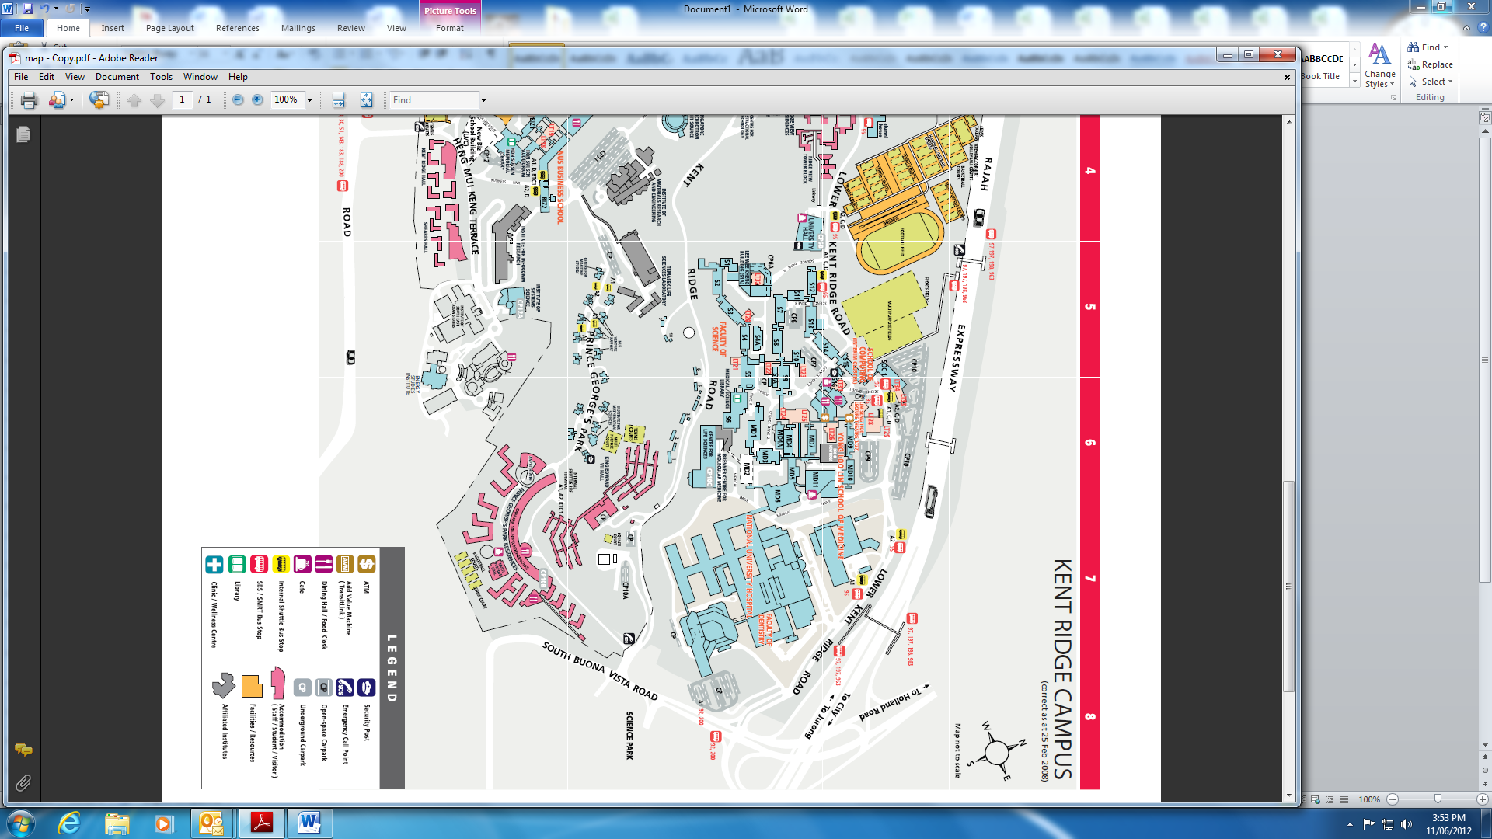
SSMB Food Pathogen workshop- Practical Session

SSMB Food Pathogen Workshop

